Labour Market
April, 2019

Table of Contents
SUMMARY………………………………………………………………………………………………….. 3
1. Labour Supply …………..……….. .4-6
- Employment
- Hours worked
- Flexible employment
- Employment by nationality
2. Labour demand 7-8
- Vacancy rate - unemployment rate
- Registered unemployment
- Long term unemployment as a ratio of labour force
- Diagram on Employment-Unemployment-Inactivity flows
3. Active Labour Market Policies 9
DIAGRAMS
1.1 Seasonally adjusted annual employment rate, 2014-2018
1.2 Seasonally adjusted annual hours worked rate, 2014-2018
1.3 Annual percentage change of employees by nationality, 2014-2018
2.1 Annual vacancy rate - unemployment rate, 2014-2018
2.2 Annual long term unemployment rate to labour force, 2014-2018

Summary
During 2018, the labour market exhibited a substantial recovery pursuing the high economic growth rate, estimated at 3.9% according to the latest projections of the Statistical Service. In parallel, all other relevant indicators support the significant improvement of the labour market.
Employment in persons and hours worked have increased on average in 2018 compared with one year earlier by 4% and 3.7% respectively in seasonally adjusted (SA) terms.
In the public sector, employment in persons in 2018 denoted a decrease as a ratio of SA employment and declined to 11.7% from 12% that stood one year earlier. The decline is wholly attributed to the increase of employment in persons. Underemployment in persons denoted on average a decrease of five percentage points in 2018 compared to 2017 and fell to 12.6% from 17.6% of the labour force.
The above promising situation in employment terms is reflected in unemployment figures. The unemployment rate denoted a significant reduction from 11.1% in 2017 to 8.4% in 2018. Youth unemployment (ages 15-24) declined by 4.5 percentage points falling to 20.2% in 2018, from 24.7% on average in 2017. Furthermore, long run unemployment as a ratio of the labour force continued its declining trend from 4.5% in 2017 falling to 2.7% in 2018.
Labour market expectations are anticipated to continue being positive during the period for the years 2019-2021 based on projections of a healthy economic activity. Thus, growth is expected to drive the employment growth higher and lead the unemployment rate lower and fluctuate around 7%-7.5% in 2019.
In parallel,

1. Labour Supply

The positive developments in the labour market continued, as average employment in persons, in SA terms, recorded an increase of 4% in 2018 compared with 2017. In 2018, employment recorded an increase of 4.0% (Figure 1.1). At the same time, underemployment as a ratio of the labour force in 2018 denoted a marked decline by 5.0 percentage points compared with 2017.

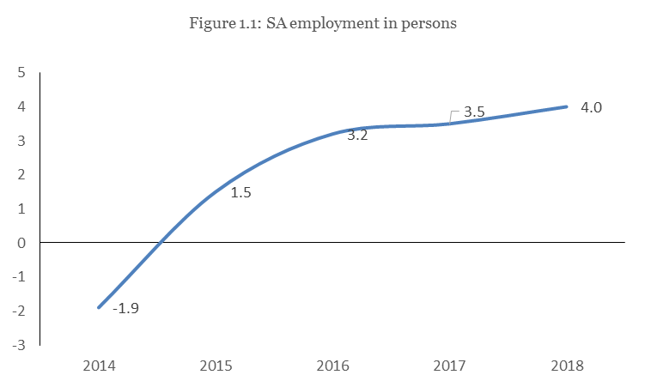

Source: Statistical Service
The seasonally adjusted hours worked exhibited a similar trend and recorded an increase of 3.7% on average in 2018 compared to 2017 (Figure 1.2).
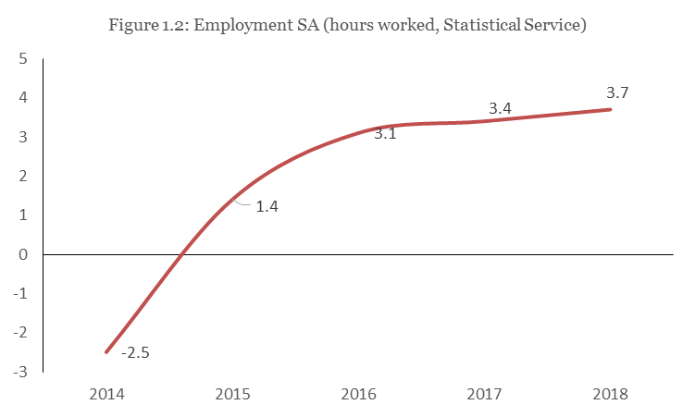
Source: Statistical Service
During 2018, on average 89.588 persons were employed in flexible forms of employment representing 20.3% of the labour force and denoting a reduction by 1.9 percentage points compared to 2017.
Employment in the public sector to total employment based on Public Administration and Personnel Department’s (PAPD) data denoted a decline in 2018 falling to 11.7% in 2018 from 12.0% in 2017.

According to data by the Department of Social Security Services (SSS), Cypriots increased on average by 1.0% in 2018 compared to 2017, while employment of Europeans rose by 2.8 percentage point and employment of third country individuals increased by 0.5% in relation to 2017 (Figure 1.3). As depicted in Figure 1.3 European and third country individuals exhibit higher mobility than Cypriots who maintain a more constant labour mobility profile reflected in relatively constant variance.

According to data by SSS, the distribution of employees by nationality was 81% Cypriots, 11.0% Europeans and 8.0% individuals from third countries.

Cypriots were employed mostly in the sectors of Wholesale and Retail Trade, Food and Accommodation services, Construction, Manufacturing and Education and to Professional, Scientific and Technical activities. European nationals were employed mainly in the sectors of Food and Accommodation services, Wholesale and Retail Trade and Construction. Lastly, third country nationals were employed by services of households as employers and in sectors of construction and agriculture.
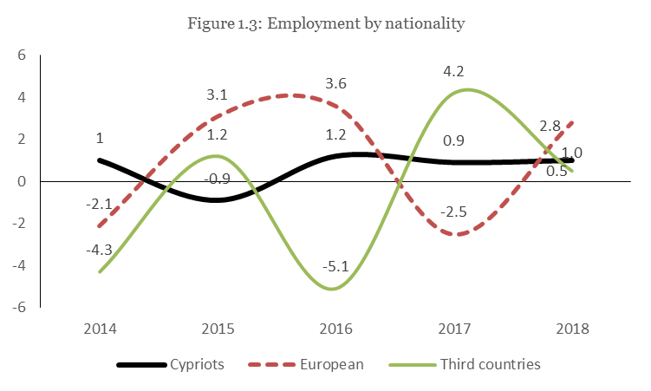

2. Labour demand
On the demand side, the vacancy rate increased on average in 2018 by 1.5%. The unemployment rate has notably reduced to 8.4% from 11.1% in 2017 and has led the Beveridge curve to shift down and rightwards causing the labour market to adjust to a new equilibrium point (Figure 2.1).
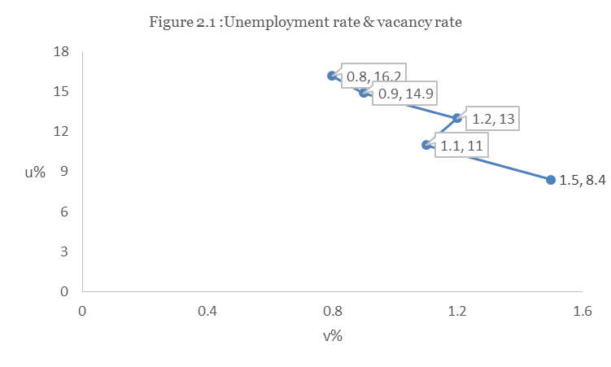

Registered unemployment in seasonally adjusted terms in 2018 on average denoted a significant decline in relation to 2017 by 6.876 persons of the labour force or by 20%.

The continuous decline of registered unemployment is expected to be reflected in a sustained reduction in unemployment benefit and redundancy outlays leading to increasing public revenue associated with higher employment impacting positively on public finances.

The marked decline in the average unemployment rate by 2 p.p between 2017 and 2018 is also reflected in the unemployment rate for persons aged between 15-24 which exhibited a decline by 4.5 percentage points in 2018 and fell to 20.2%, while long term unemployment also declined by 1.8 percentage points falling to 2.7% of the labour force. (Diagram 2.2).
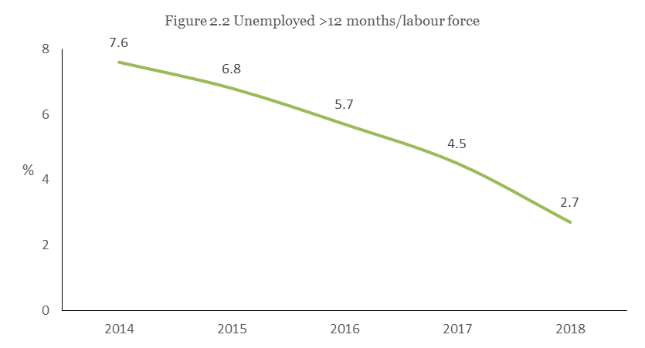

Source: LFS
Employment-Unemployment-Inactivity flows
Based upon the quarterly data published by Eurostat, the Employment, Unemployment and Inactivity flows are monitored so as to record the number of persons moving in and out of the corresponding pools and thus identify the relative transfers.
Under this scope it could be pinpointed the net number of persons moving in and out of the relevant pools and thus, it can be an additional component of the current quarterly labour market analysis.
The attached diagram is based on data of the 4th quarter of 2018 in relation to the 3rd quarter of the same year. Each pool of the three maintains a starting number of persons (stock), which changes according to the moving flows.
The concluding remark that can be reached by the below diagram is that between 2018q4/q3, the net flows of employment and unemployment remained unchanged.
It is worthwhile noting, that 2.000 persons moved to net inactivity from employment.

8.000

10.000

9.000 7.000

2.000

2.000

UNEMPLOYMENT

23.000

INACTIVITY

200.000

EMPLOYMENT
388.000

- Net increase in employment 0 persons.
- Net increase of unemployment 0 persons.
- Net increase of inactivity by 2.000 persons or net decrease in activation by 2.000 persons.

Active Labour Market Policies

Active Labour Market Policies are effective measures used to reduce the number of unemployed persons and thus the unemployment rate. The purpose of these schemes is the reactivation of the unemployed through retraining and linking benefits to active participation in the labour market.

It is noted that the role of these schemes is catalytic amid high unemployment and also in periods of relatively low unemployment, thereby raising training and acquiring additional skills for all participants matching those skills to labour demand characteristics.

The active labour market policies reflected in specific schemes are targeted depending on the priorities set by the government in association with the needs of the economy and are financed by national funds and/or co-financed by the European Social Fund of the European Union.

Current ALMPs are targeted towards specific vulnerable groups such as unemployed, unemployed beneficiaries of GMI, youth under the age of 30, long term unemployed and long term unemployed public assistance beneficiaries.
In the Table attached, the current and future active employment schemes are listed for the period 2015-22 for which total budgeted expenditure is estimated to €112.4 million while for 2018 the total budgeted amount equals €15.8 mln.

ACTIVE LABOUR MARKET POLICIES

Flexible forms of employment include the number of employees working part time and on temporary contracts.
Source: Social Security Services
The Beveridge curve or UV curve represents a graphical illustration of the relationship between the unemployment rates with vacancy rate (the number of empty jobs to the labour force).
Source: Department of Labour and Human Resources Development Authority

